Creating a new VPC . VPC is a logically isolated virtual network that we define. It acts as our own private network within the AWS cloud, giving us control over IP address ranges, subnets, route tables and network gateways.

Here I have created new VPC with my name.
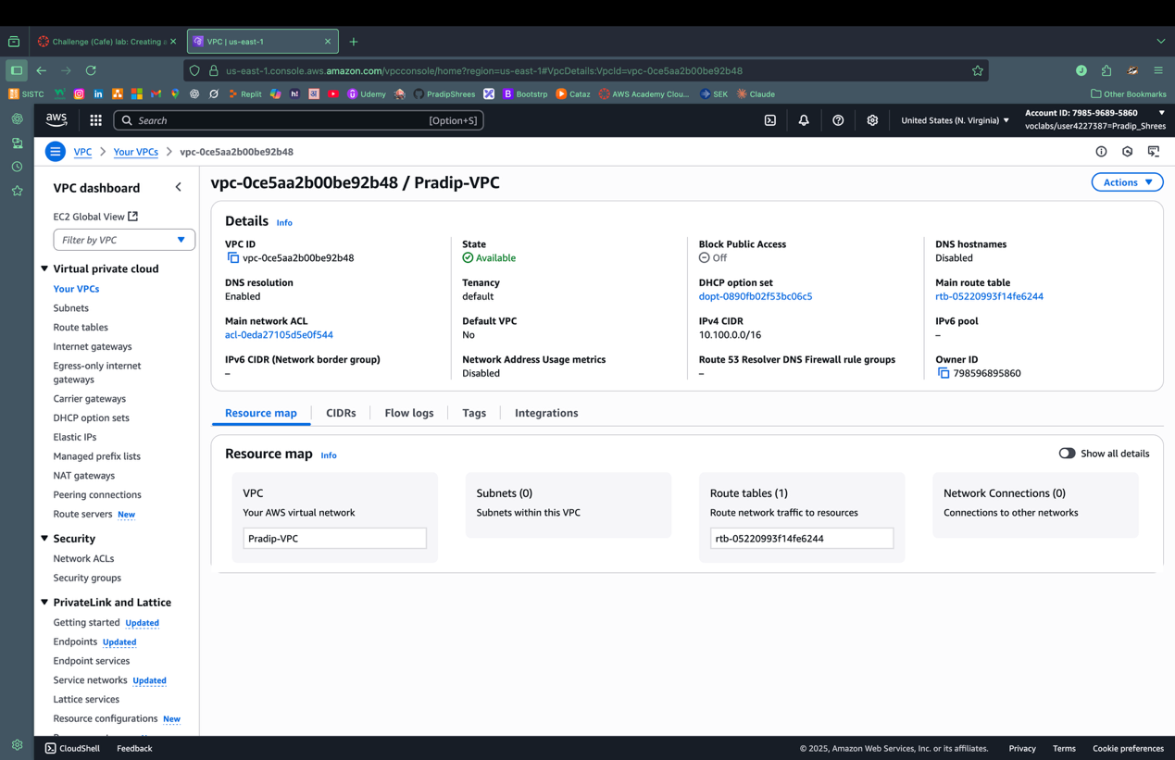

In this step, I have created an Internet gateway with my name. An internet gateway allows communication between resources inside your VPC and the public internet.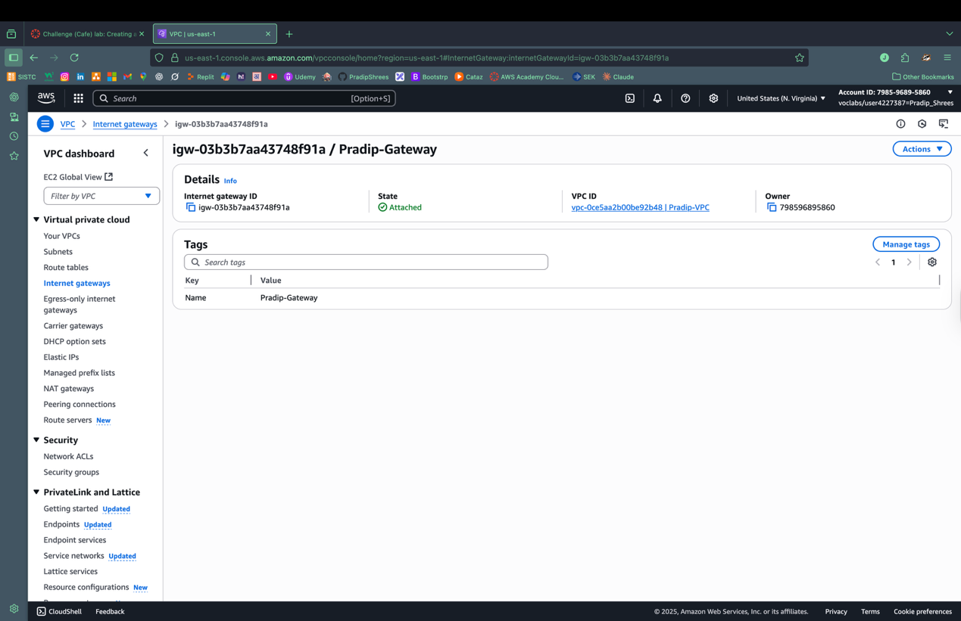

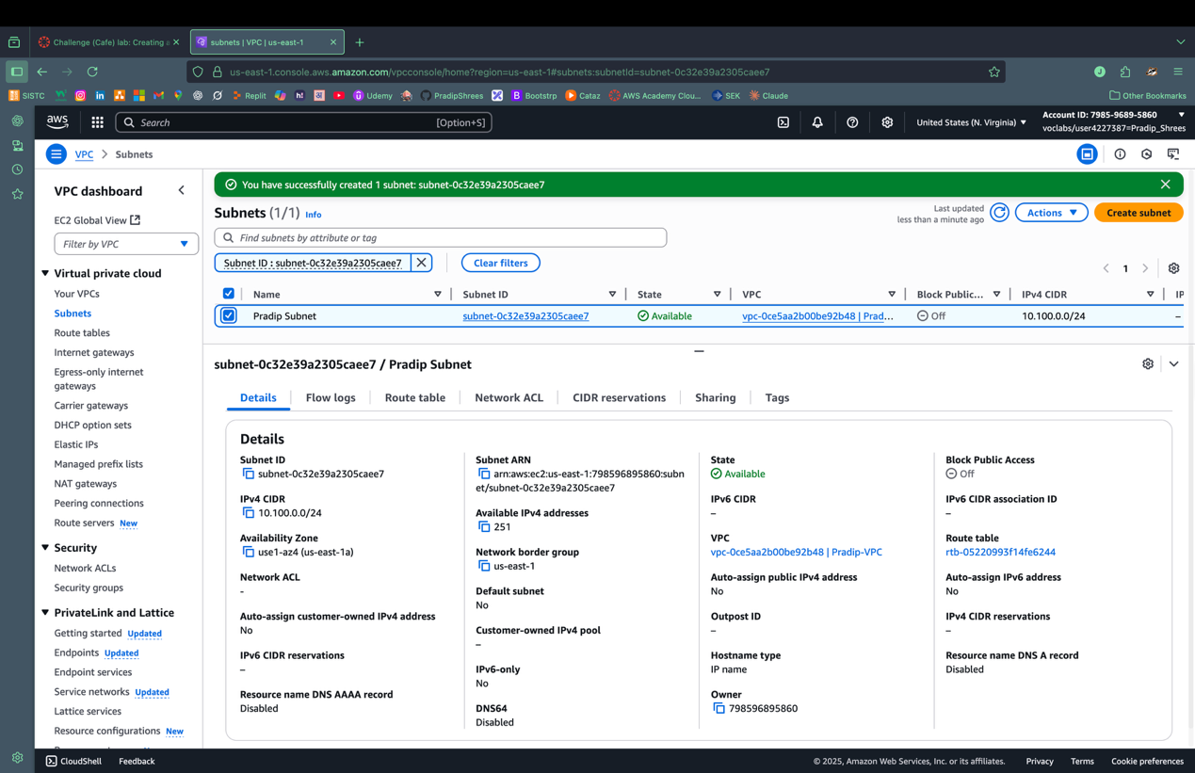
Creating a subnet allows us to divide the provided IP into many logical subdivision of your VPC’s IP address range. It is done using CIDR.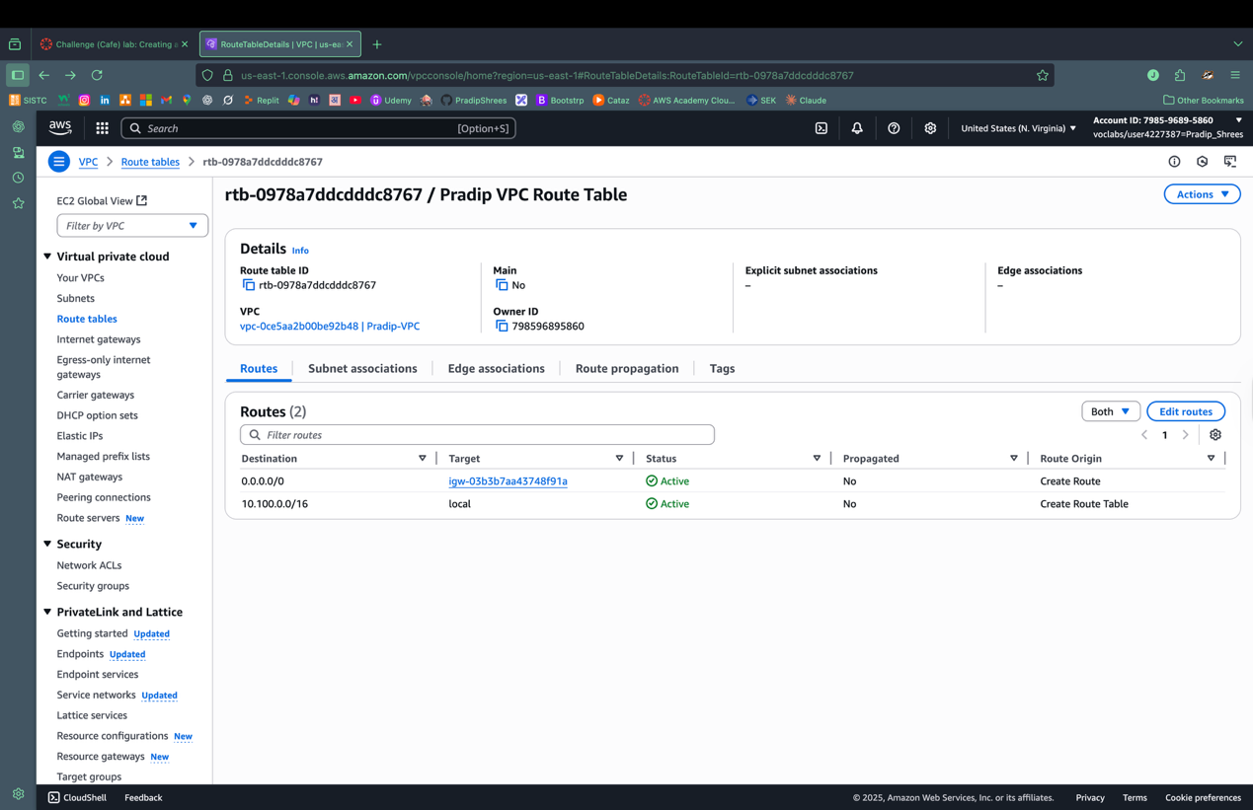
This is the resource map that shows my VPC that has subnet, a routable and gateway.

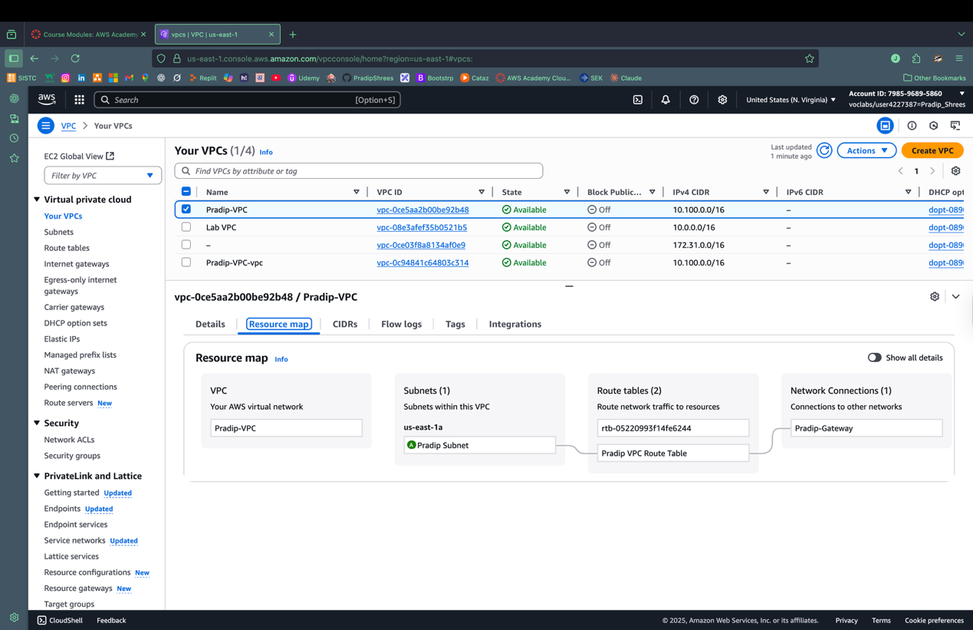
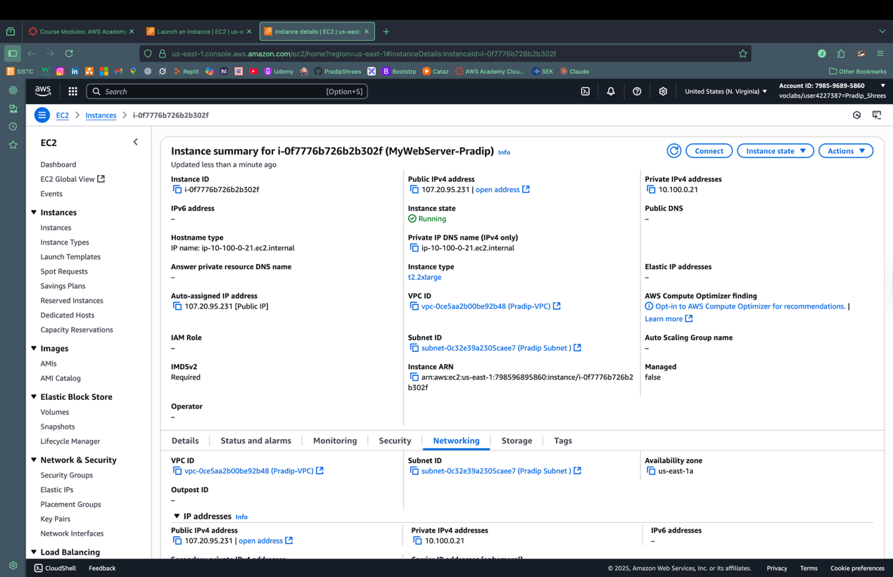
After creating VPC, we created an instance. This instance is connected to my VPC.

